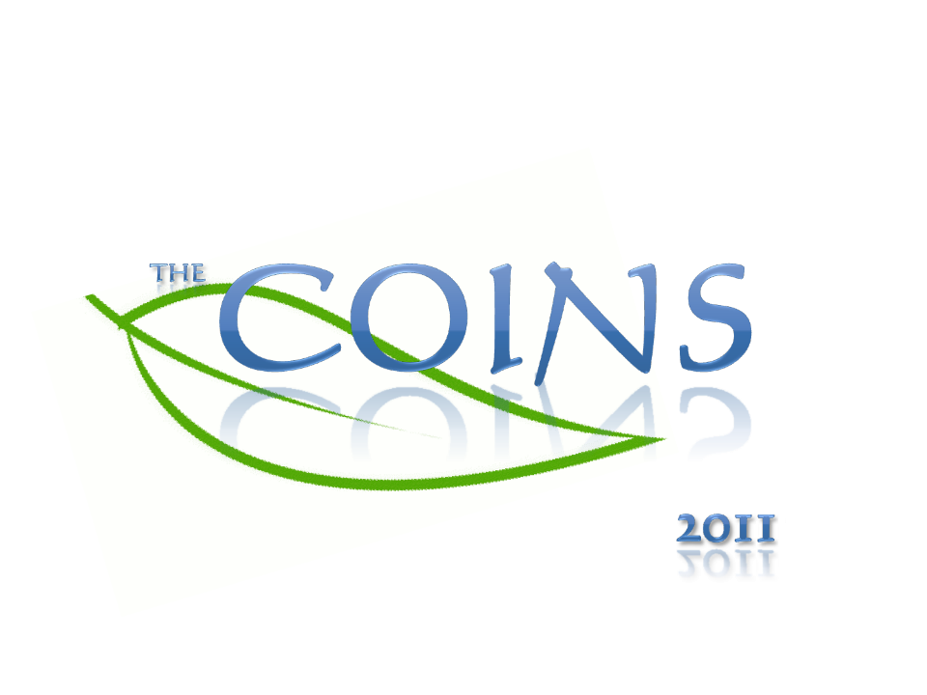

Invitation to International Student`s Conference of Natural Sciences
“The COINS 2011“
September 20-24th, Vilnius University, Faculty of Natural sciences/ Faculty of Medicine
Dear Colleague,
For the 8th time Vilnius University, Faculty of Natural sciences in cooperation with Faculty of Medicine is organizing an annual International Student‘s Conference of Natural Sciences “The COINS 2011“. It is an honor for us to invite you to this educational event, which will be held in September 20-24th, 2011. The Conference will appear as internationally active, politically neutral and intellectually objective event, where students have a great chance to sparkle as perspective scientists. Active students from Vilnius University with the help of lecturers will try to share their experience with participants, give advices related to their presentations.
“The COINS” is engaged in an extensive composition of activities that give an opportunity for
bachelor and master students to present their researches to international audience in English. By
creating opportunities for dialogue and collaboration between students and jury, "The COINS"
serves a platform for knowledge sharing, cultural exchanges and open-minded discussions. This
year we have sliced conference in three sections:

Life sciences – biochemistry, biophysics, molecular biology, genetics, biotechnology
Enviromental sciences – ecology, ecophysiology, enviromental chemistry, botany, zoology
Medical biology – microbiology, genetics, molecular oncology, laboratory medical biology, cytology

All the participants will have a chance to introduce their projects according to the topic they work
on. The conference offers a great chance to select the way of participation: to attend 5-10 min lasting poster session – the exhibition or to give a presentational speech to the audience.

The COINS 2011 is not only a conference. It is a huge step towards seeking wider and deeper.
Netherless, it is a lovely place where scientists and students meet and share their knowledge,
experience and can expand their horizons in cultural understanding.
English is the main language during the conference.
The fee for a participant from foreign country is 30 euro. We accept people from Lithuania to participate in this event free of charge.
Registration is open! The deadline is the 30th of June.
Yours sincerely,
Jekaterina Cvetkova
The COINS’11 conference coordinator
If you have any further questions, please do not hesitate to contact us at:
Tel. +370 0560219
E-mail: jekaterina1989@gmail.com

