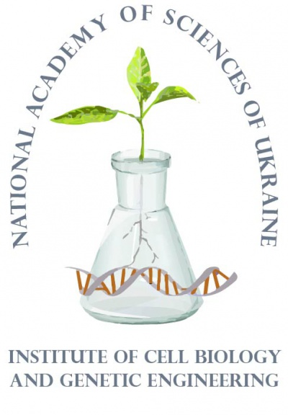 | Radiobiological Society of Ukraine | 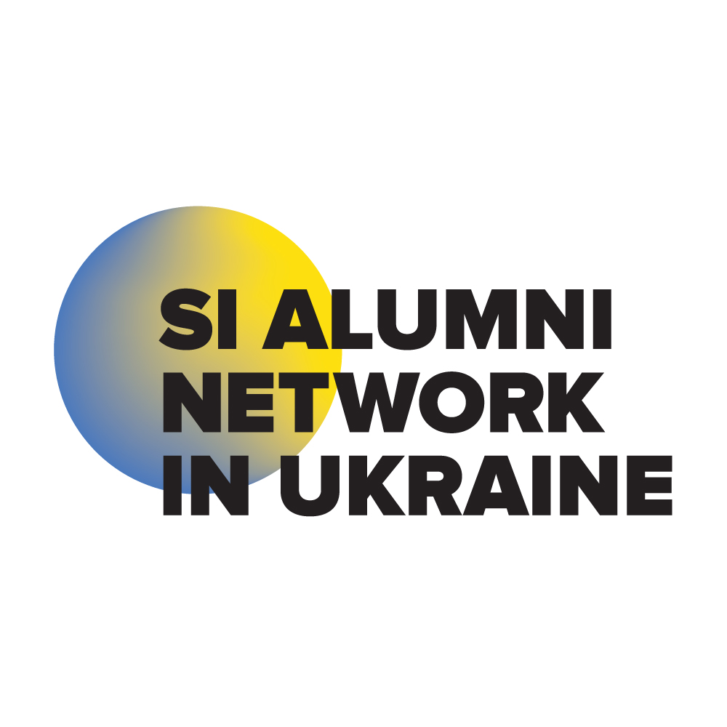 | 

Institute of Cell Biology and Genetic Engineering NAS of Ukraine
Radiobiological Society of Ukraine
Swedish Institute

“CLEAN WATER AND REMEDIATION TECHNOLOGIES. FOCUS ON CHORNOBYL DISASTER AND ANTHROPOGENIC POLLUTION”
Kyiv, April, 23, 2019

Dear Colleagues!

We are glad to invite you to participate at Workshop on “Clean water and remediation technologies. Focus on Chornobyl disaster and anthropogenic pollution”

Venue: Institute of Cell Biology and Genetic Engineering,
143, Acad. Zabolotnogo Ave, Kyiv, Ukraine 03143

Time: Tuesday, April, 23, 2019

Workshop Organizers:
Institute of Cell Biology and Genetic Engineering NAS of Ukraine (ICBGE)
Radiobiological Society of Ukraine (RSU)
Swedish Institute (SI)

Workshop Areas:
- water resources in Ukraine and Europe
- radioactive pollution of waters including contamination from Chornobyl disaster
- chemical and other anthropogenic pollution in waters
- biological and health effects of polluted waters
- water biodiversity
- clean water and sanitation, including purification and remediation technologies
- agriculture and sustainable water management
- water resources and global climate changes
- international cooperation in decision of water problems

Participants will also have an opportunity to meet Swedish Institute alumni who will share the knowledge about water cleaning and sanitation in Sweden. Their personal research, study, and intercultural exchange experiences, knowledge about the possibilities of studying and doing research in Sweden will be great opportunity for young scientists and students.

The program includes:
keynote speakers, speakers, young scientists’ presentations, presentations from Ukrainian SI Alumni, on-line presentations, reporter speech.

Workshop Web-site: You may find more information about the workshop at http://www.icbge.org.ua

Abstract Book: Accepted abstracts will be electronically published via the workshop website in the abstract book by the beginning of the workshop.

How to participate: To participate in the workshop it is necessary until March, 20, 2019:
- to fill a registration form on ​​https://docs.google.com/forms/d/e/1FAIpQLScCxTmQXjM-eelMjTor00rwOtIZSFKjGOd8ZtmmrIlrXWdtCg/viewform?usp=sf_link
- to send an electronic abstract prepared according to the text style requirements to e-mail of organizing committee radiobiology2015@gmail.com (Appendix).

All the notifications will be sent to the e-mail address according to the submitted application form. Event acceptance notification will be sent at April 4, 2019. If you have not received the confirmation, please, contact the organizing committee via e-mail radiobiology2015@gmail.com

Participation in the seminar is free of charge!

Abstract format:
Abstracts must be typed in Microsoft Word, saved as file in "RTF" format, under the surname of first author in Latin characters (for example, Vinichenko.rtf).
Abstract should not exceed 1 page and can be written in English or in Ukrainian. Page format – A4, all margins 2.5 cm, font Times New Roman, single spacing (see Appendix “Abstract template”).

The Program Committee retains the right to decline papers which are out of the scope and topics of the workshop, do not respect the style requirements or submitted after deadline. Abstracts that are not formatted according to the mentioned rules or arrived after deadline will not be considered. The paper acceptance for publication will be confirmed via email address specified in the registration form as the corresponding person’s contact.

Program Committee:
Dr. Namik Rashydov, Dr.Sc., Institute of Cell Biology and Genetic Engineering, Kyiv
Dr. Oleksandra Kravets, Dr.Sc., Institute of Cell Biology and Genetic Engineering, Kyiv
Dr. Dmytro Gudkov, Dr.Sc., Institute of Hydrobiology, Kyiv
Prof. Oleksii Dugan, Dr.Sc., Igor Sikorsky Kyiv Polytechnic University, Kyiv
Dr. Oleksii Khudyi, PhD, Yuriy Fedkovych Chernivtsi National University, Chernivtsi
Dr. Yulia Kutsokon, PhD, Institute of Zoology, Kyiv
Dr. Yuriy Kvach, PhD, Institute of Marine Biology, Odesa
Dr. Sevil Mamedli, PhD, Institute of Radiation Problems, Baku (Azerbaijan)
Dr. Oleh Marenkov, PhD, Oles Honchar Dnipro National University, Dnipro
Prof. Alla Pryshchepa, PhD, National University of Water and Environmental Engineering, Rivne
Dr. Mykola Svitelsky, PhD, Zhytomyr National Agroecological University, Zhytomyr

Organizing Committee:
Dr. Nataliia Kutsokon, PhD., Institute of Cell Biology and Genetic Engineering, Kyiv
Dr. Iryna Yermakovych, PhD, O.M.Beketov National University of Urban Economy, Kharkiv
Olena Nesterenko, Institute of Cell Biology and Genetic Engineering, Kyiv
Yulia Khoma, Institute of Cell Biology and Genetic Engineering, Kyiv
Maryna Kryvokhyzha, Institute of Cell Biology and Genetic Engineering, Kyiv
Sergii Litvinov, Institute of Cell Biology and Genetic Engineering, Kyiv
Bohdana Kozubenko, NGO “Gladio”/Product Safety at Amazon, Smila/Gdansk

Partners:
• SI Alumni Network in Ukraine
• NGO Ukrainian Water Society “WaterNet”

Informational support:
• Embassy of Sweden in Ukraine

Important deadlines:
March, 20, 2019 – Abstract and registration form submission deadline
April 4, 2019 – Workshop acceptance notification, second information letter will be placed at workshop web-page
April, 23, 2019 – Workshop

For more information please contact:
Dr. Nataliia Kutsokon, secretary of the workshop, Institute of Cell Biology and Genetic Engineering, 143, Acad. Zabolotnogo Ave, Kyiv, Ukraine 03143 E.mail: radiobiology2015@gmail.com (preferable),
tel. +38044 257-82-44, fax: +380 44 5267104

WELCOME TO THE WORKSHOP!
Appendix

ABSTRACT TEMPLATE
Page format – А4, all margins – 2.5 cm, font Times New Roman, single spacing

Title of the Abstract (14 pt, Times New Roman Bold Centered)
Author¹ (First Name SURNAME), Author², Author³, ...... (12 pt, Times New Roman, Centered, corresponding author’s name underlined)
Example:
Nataliia KUTSOKON¹, Olena NESTERENKO¹, Namik RASHYDOV^{1,2}
¹Department of Biophysics and Radiobiology, Institute of Cell Biology and Genetic Engineering, Kyiv, Ukraine (11 pt, Times New Roman, Centered)
² NGO “Radiobiological Society of Ukraine, Kyiv, Ukraine (11 pt, Times New Roman, Centered)
eeee@xxxx.com (Email of the corresponding author (11 pt, Times New Roman Italic, Centered)

Aim of the study: This section must describe the main objective of the study (12 pt, Times New Roman, Justified)
Material and Methods: This section must describe material and methods used in the study (12 pt, Times New Roman, Justified)
Results: This section must describe the main results of the study (12 pt, Times New Roman, Justified)
Acknowledgements (if any): This section should describe financial supports (as organization, institute, project number) and the persons who contributed to the current study (12 pt, Times New Roman, Justified)
Please note that the abstract should not contain the list of literature sources
Keywords: keyword 1, keyword 2, ...... (11 pt, Times New Roman, Justified) (max. 6 words)

ABSTRACT MUST NOT EXCEED ONE PAGE

